Question 1

[org 0x0100]

jmp start

functionn:

add al, [number + bx]

add bx , 1

sub cx ,1

jnz functionn

ret

start:

xor ax ,ax

mov cx ,7

mov bx , 0

call functionn

mov ax,0x4c00

int 0x21

number: db 1,2,1,1,1,1,1

Screenshot

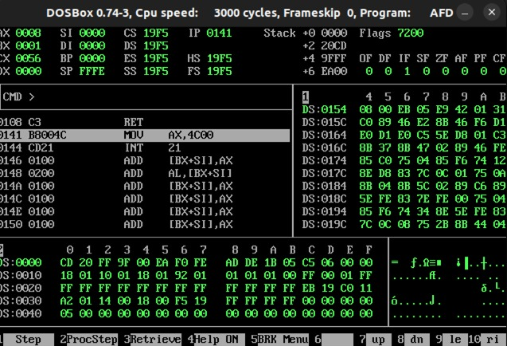

Question 2

Code

[org 0x0100]

jmp main

mply:

mul bx

mov [multiply], ax

ret

dvi:

div bx

mov [division], ax

ret

main:

mov ax,5

mov bx, 5

push ax

push bx

call mply

call dvi

mov ax, 0x4c00

int 0x21

multiply: dw 0

division: dw 0

Screenshot:

end

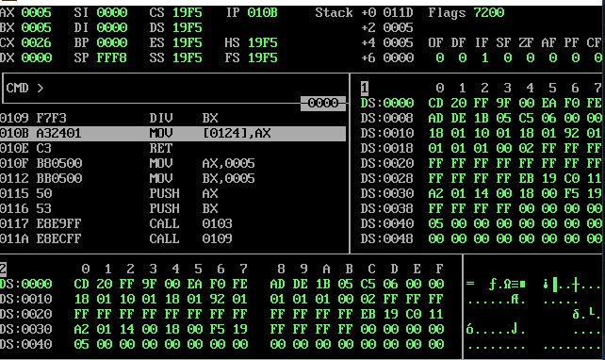

start

